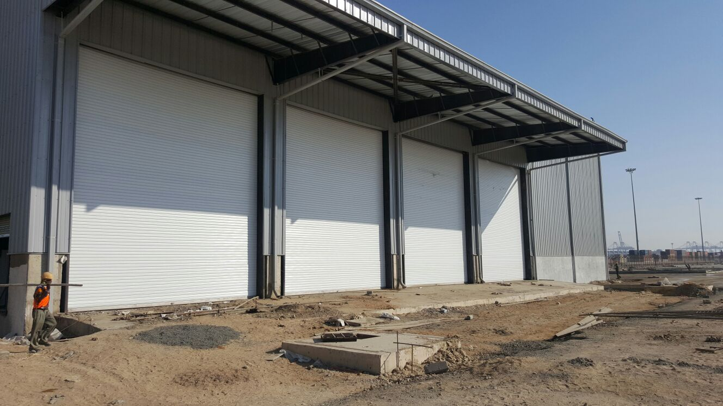

NIHVA – Gear Operated Rolling Shutter
Description:

Gear Operated Rolling Shutter with Galvanised Steel Laths with thickness of 1 mm.

Mounting Location area

Inside area / Outside area

Mounting Surface

Side Brackets: Optional = On Concrete /Steel & Side

Curtain Panel
The panel made of 1.0mm thick GI steel

Curtain panel size
75mm wide

Curtain Profile
Curved

Bottom Profile
M. S. Plate 100 mm x 2.5 mm thick with angle stiffener

Side Guide Profile
M.S." U" Shaped profile 65 mm -150 mm x 3 mm thick (as per the opening width dimension)

Roller Shaft
M.S. Tubular Pipe with Flange & machined shaft at the ends Pipe Dia -100 to 300 mm as per w x h

Side Brackets
MS Plate 3 mm to 10 mm thick , as per the opening dimension

Hood Cover
Made of GI Sheet Thickness 0.8 mm with 25x25x3mm angle stiffener

Surface finish

2 Coats (each coat of 35 microns DFT) of EPOXY polyamide based enamel finish of approved color and make over a Coat (each one coat 25 microns DFT) of EPOXY polyamide based red oxide zinc phosphate primer

Gear Assembly

